Getting Eclipse installed
A Special Note About Eclipse and Java:
As of fall 2018, Oracle has ended support for JDK 9 and 10, and this course has not yet been tested against later JDK versions. Instead, we’re going to install JDK 8. Therefore, please click the link in Step 1 instead of Googling “JDK”.

If you already have some version of JDK installed on your computer, you are welcome to jump straight to Step 3 that asks you to download and install Eclipse. However, if you encounter errors, please jump back to Step 1 and install JDK 8.

If you run into trouble, please check out the FAQ page.

- First, before installing Eclipse, we need to get Java installed. Go to https://web.cs.wpi.edu/~jmcuneo/jdk/. Click the appropriate .exe file (Windows) or .dmg file (Mac) in the list to download it.

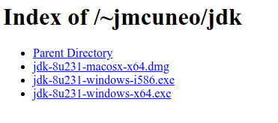
NOTE: If you are installing on Windows, choose i586 for 32-bit systems or x64 for 64-bit
systems. Unless your computer is very old, you’re probably on a 64-bit system.

- Double-click the file to run it. It will take you through an installation wizard, where you can keep all of the defaults. Ignore any messages about a roadmap. Click “Close” when the installation is complete.

- Navigate to https://www.eclipse.org/downloads/ and download Eclipse for your operating system.
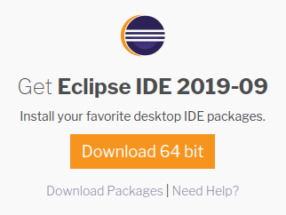

- That should download an installation file. Double-click the file to run it. When prompted to select a version of Eclipse, please choose Eclipse IDE for Java Developers. Accept all other defaults and all licenses. If the installer takes awhile to open and/or run, please be patient until it finishes.

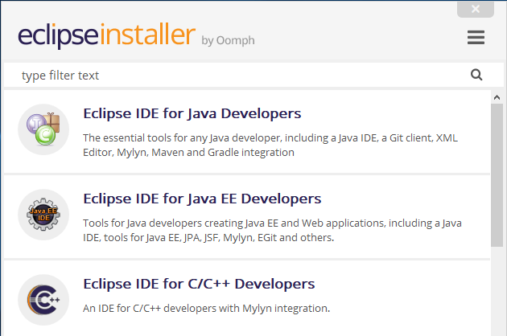

- When you open Eclipse for the first time, it will ask you for your workspace directory. We recommend that you create a CS2102 folder on your computer to keep all of your projects, homework assignments, and labs in.

- Optional: Eclipse (like most IDEs) has keyboard shortcuts that make common tasks easier to perform. Mastering these shortcuts will make you a quicker developer. A quick Google search will give you an extensive list of the ones available.

Creating a new Java project
For this class, you will create a new Java project for every assignment. This includes homeworks and labs. These instructions will walk you through that process.

- When Eclipse starts, you’ll be greeted by a screen that looks something like the picture below:

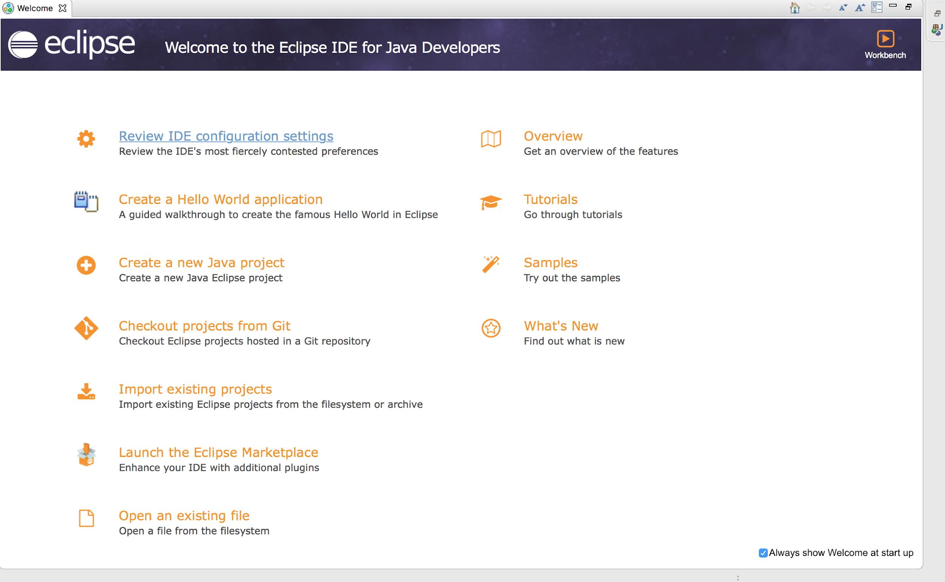

- In order to create a new project, click File -> New -> Java Project.

Mac:
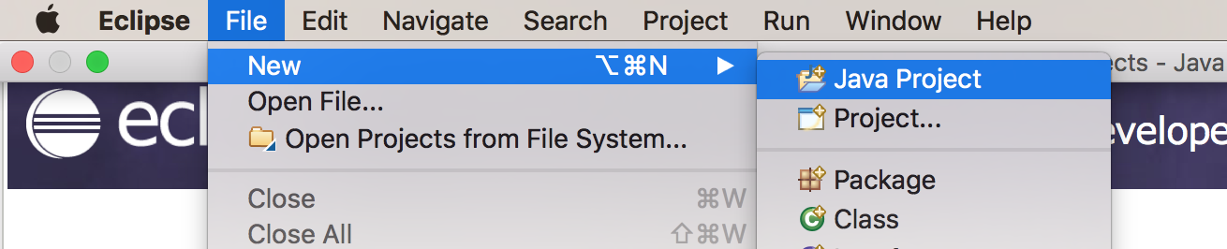

Windows:
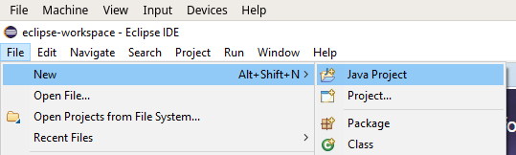

NOTE: If Java Project does not appear in the context menu as shown in the screenshots above, click File -> New -> Project and select Java Project from the list, then click Next.

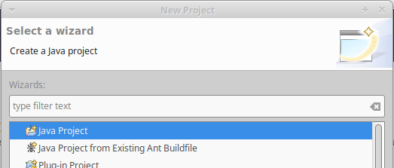

- On the next screen, you’ll have to name your project in the text area named Project Name. You should also check that the JRE selected shows JavaSE-1.8. This is next to the label Use an execution environment JRE:

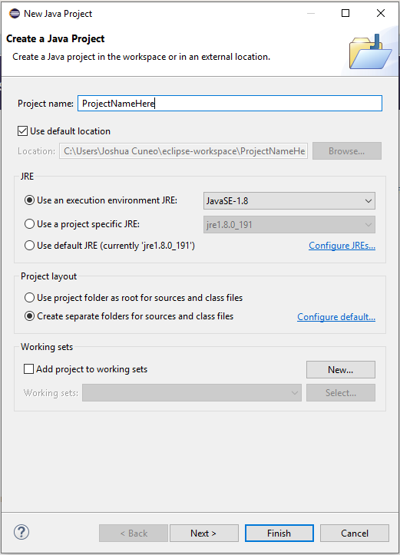

- Once you name your project and have the JRE selected properly, you can hit Finish. You do not need to adjust any other settings in this window.

- If you close the Welcome message on the top left, you can see your screen is now split into 2-4 main panels (this depends on settings but you will always have the important two I’ll discuss here). The tall one on the left is the project navigator and the big square area on the right is where we will eventually write our code.

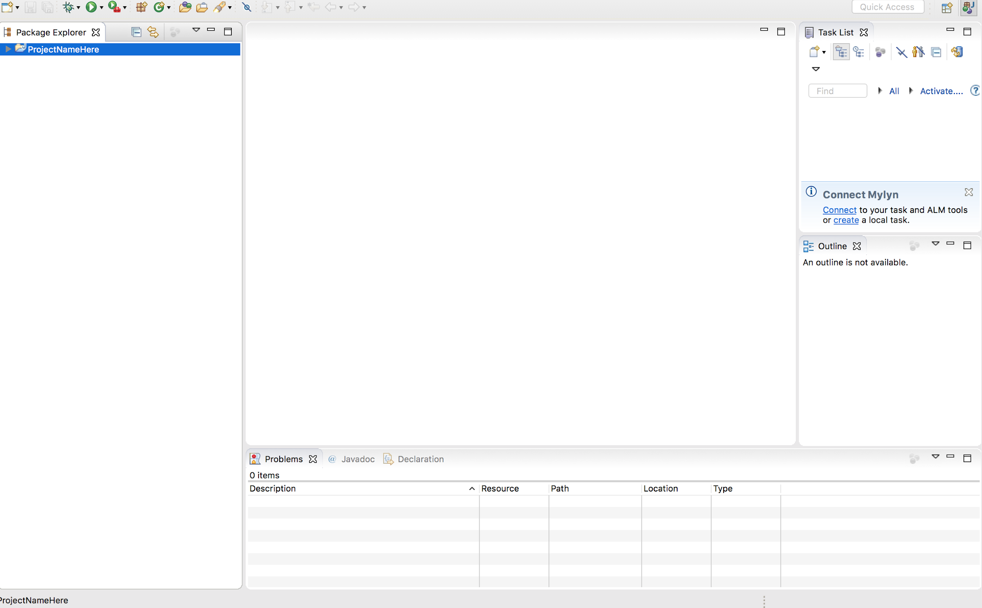

- Congratulations! You now have your project set up!

Creating new classes, interfaces, etc.
- Once your project is set up, you can click on the little triangle next to your project name in the project navigator. This will show you the contents of the project. We will write all of our code within that src folder.
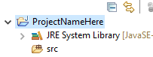
- Eclipse expects that every class, interface, or other Java construct is in its own file. This keeps our code more organized but also means we could potentially have a good number of files in our project. In order to create a new code file, we will right click the src folder and select New… -> Class. You can do the same thing for interfaces, enums, etc but will have to click on whatever construct you want.

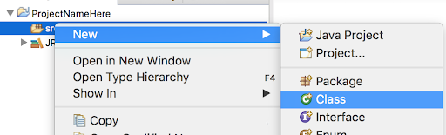

- On the screen that opens, all we should have to change is the ClassName. You can enter that in the text area next to the label Name:. Once you’ve entered your class name you can hit Finish.

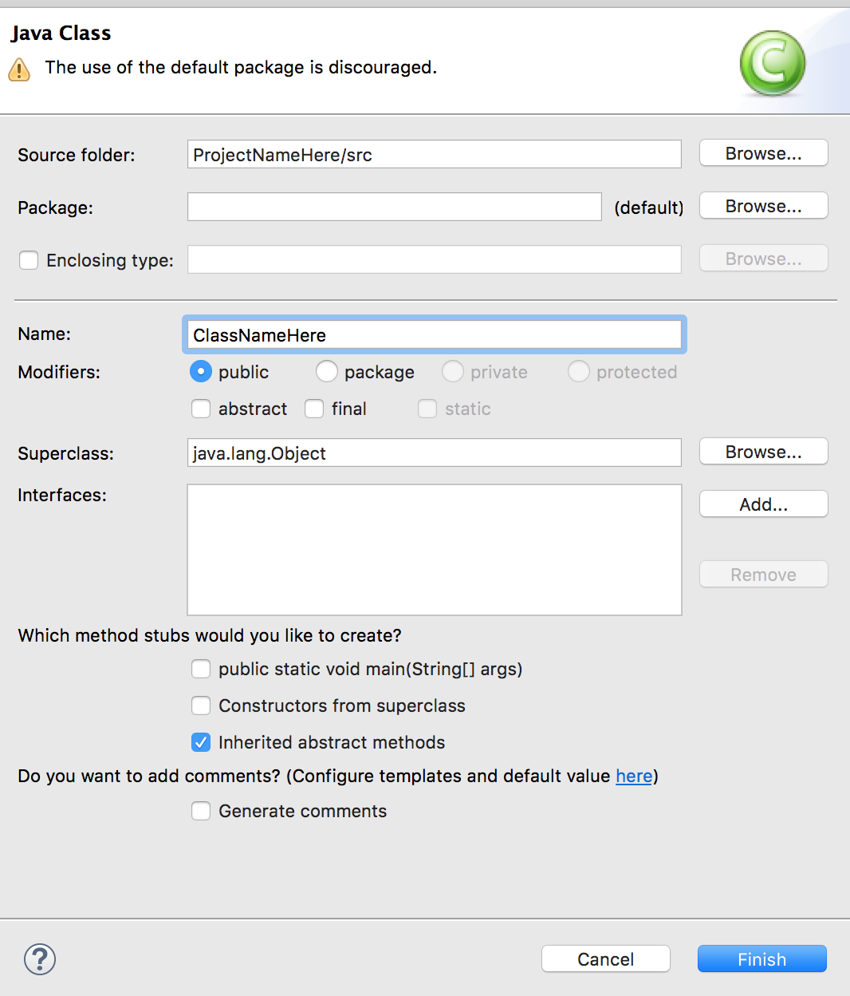

- You’ll notice that you can now drop down the src folder to reveal the (default package) and our new Java file. It’s very important that your code is in the default package here. You’ll also notice that Eclipse opened our new Java file in the large area in the right.

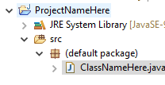
- Congratulations, you have now created your first class in Eclipse!

Setting up JUnit
- JUnit is a popular testing library. It is widely used within industry and the rest of the Java community, and it comes bundled with Eclipse. To use it, let’s make a test class to hold all of our tests. We will call this Examples in all of our projects. In order to create this, right click the project in the project navigator and click New -> JUnit Test Case.

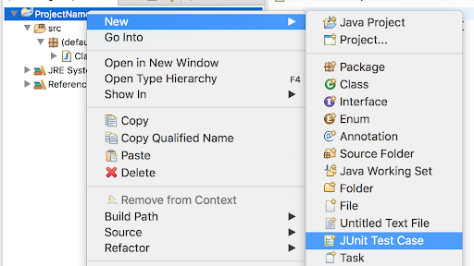

- The next screen should look very similar to the screen you saw when we created a new class. Make sure that New JUnit 4 test is the one selected. You just need to name the Test Case ‘Examples’ and hit Finish.

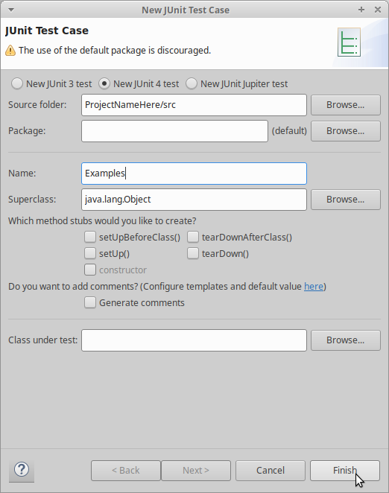

- If you receive a pop-up about the build path, please select “Perform the following action”, make sure the highlighted item says “Add JUnit 4 library to the build path”, then click OK.

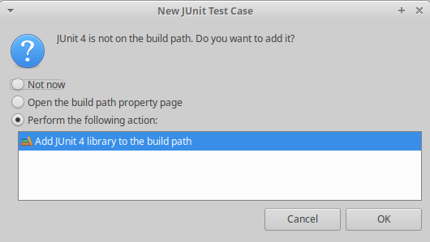

- This will generate the code you see below. This has a lot of stuff but for now, all you need to know is that this is the file where we will write all of our tests. We will talk more about the test structure in the next section.
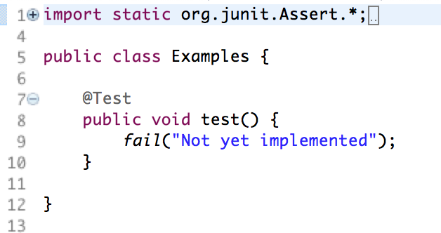

- In order to run our tests we can right click Examples and click Run as -> JUnit Test
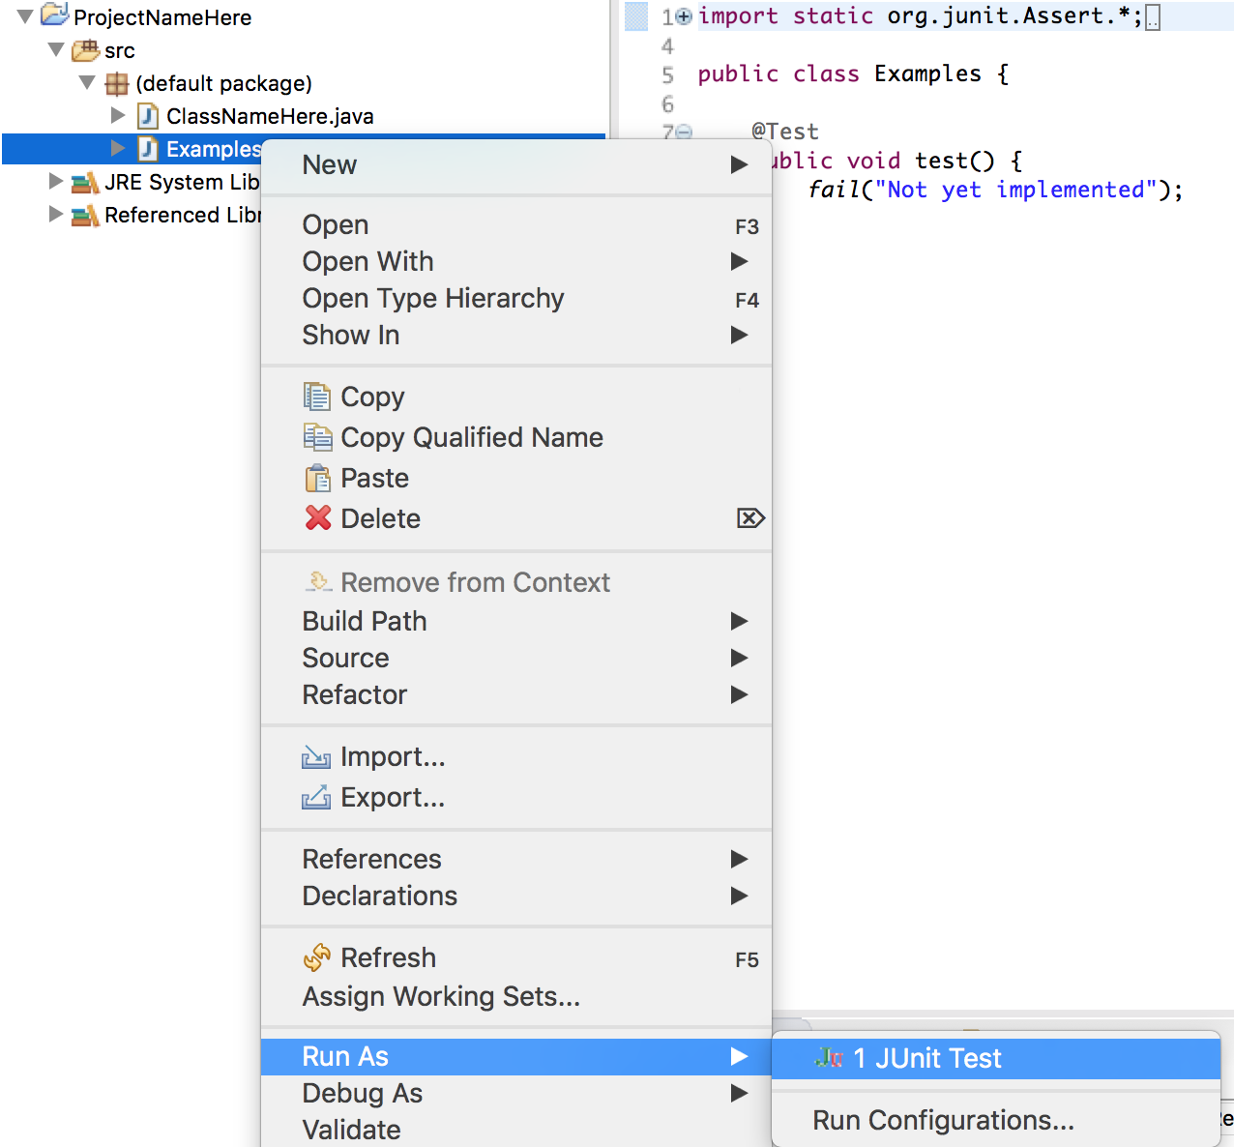

- A new panel will open in the spot where your project navigator is. This shows a summary of your tests. It shows you how many tests were run, which results in errors, and which resulted in failed tests. The goal is for it to run all the tests with no errors and no failed tests. If that happens, the red line will be green instead.

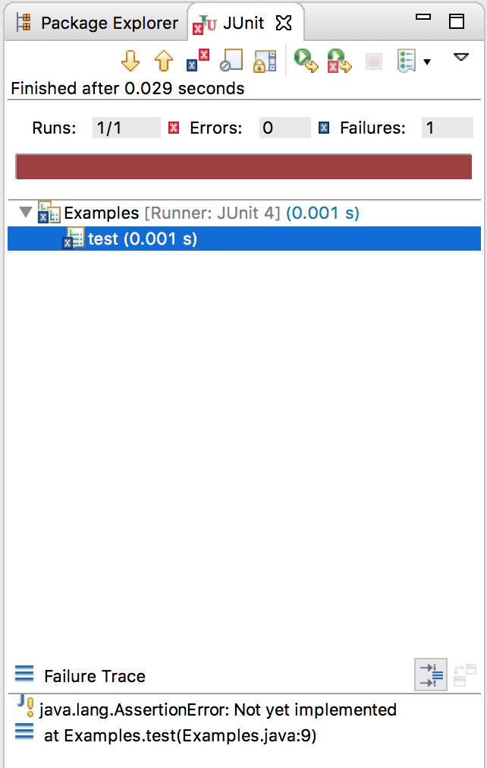

Creating Test Cases
- Now that you have your project set up, you can get to work. If you write test cases before you implement your methods, it can make it easier to write the implementation. You’re not required to program in any specific order, but regardless of whether you start with or end with test cases, you’ll have to write some. For this, we will use JUnit, which is an industrial standard used mainly for Unit Testing.

- In your Examples class, you should have your imports and a dummy test case. Every test case will follow this pattern. The @Test annotation tells the compiler that the next method is a test case and should be treated as such. After that annotation, you’ll have a method with some assert statement in it. For now, we will only be using assertEquals but know that there are other ones such as assertNotEquals and more.

- assertEquals takes in two or three arguments, depending on if you’re comparing doubles/floats or not. The first two parameters are the two things to compare. The third parameter is only used when those first two things are doubles or floats. The third parameter is a tolerance. For example, if your two values are 1.00049 and 1.0005, you would typically like these to be equal. This is where the tolerance comes in. If you use 0.001 as the third parameter, it will compare the two values up to the thousandths place.

- Here is the dummy test code for reference again:

@Test
public static void test() {
fail(“Not yet implemented”);
}

- We can replace the fail line with an assertEquals to create a legitimate test case.

- You can add as many tests as you need or want in your Examples class as long as they all follow this pattern.

